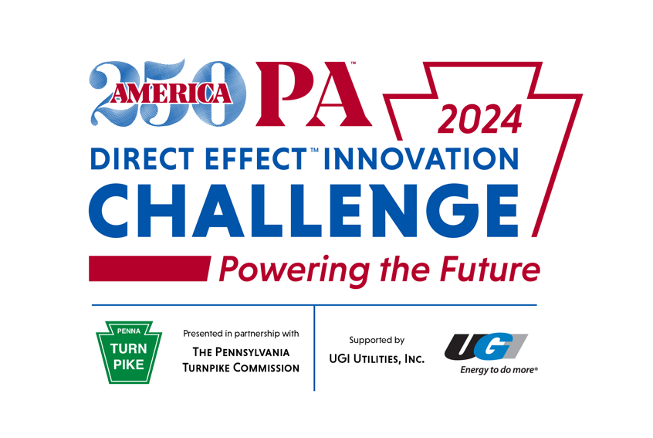

DEIC CONCEPT SHEET
To be submitted at the end of Round 1

Instructions:
Welcome to Round 1 of the 2024 DEIC: Powering the Future. Creating and submitting your 1-3 PAGE DEIC CONCEPT SHEET is the first step to building a successful campaign! Your DEIC Concept Sheet should be used during Round 1 of the DEIC, and as a guide for the rest of your team's DEIC experience. Please use the provided DEIC Concept Sheet Template, or create your own (making sure to include all of the requirements).
Using the submitted concept sheets, each institution will select one team of four (4) students to represent
their school in Round 2. By 11:59 pm on October 4th, each institution should email their team’s selected
DEIC Concept Sheet to DEIC@AMERICA250PA.ORG with the subject "2024 DEIC CONCEPT" + your institution's name.
Each Concept Sheet must include:
- Concept Title
- Selection of Marketing Channels (see the attached DEIC Concept Sheet Template below for more details)
- Description: In 1-2 paragraphs, describe your team’s idea for an original, integrated marketing campaign promoting the PA Turnpike’s adoption of solar energy, raising awareness about the benefits of solar power and encouraging interest in sustainable transportation solutions.
  - In your description, please also briefly explain how your integrated marketing campaign
will fit this year’s challenge theme.
- Insight: Create a visual that represents your idea and describe it in a 2–3 sentence caption.
  - Your visual might be a logo, photo collage, artistic creation,
or any other visual that encompasses your campaign’s mission.
- School Information
  - Name of School
  - Names, emails, mailing addresses and t-shirt sizes of the four (4) students on your team
  - Name, email, mailing address and t-shirt size of your faculty or staff mentor
  - Please specify your main Point-of-Contact (POC)
  - Please also submit a high-quality PDF or EPS file of your school’s logo (approved by your institution)
with your concept sheet
(this will be used on social media and to promote your team during the DEIC)

DEIC CONCEPT SHEET TEMPLATE
To be submitted at the end of Round 1

School Information:
Name of School:
Team Information:
 | Name | Mailing address (note: this will be the location that any potential stipend is sent) | Email | T-shirt Size | POC
Faculty/Staff Advisor |  |  |  |  | ☐
Student |  |  |  |  | ☐
Student |  |  |  |  | ☐
Student |  |  |  |  | ☐
Student |  |  |  |  | ☐

Concept Title:

Marketing Channels (please select a minimum of 3 channels):
MOBILE  In-app  Banner ads  Messaging apps | PRINT  Posters  Flyers  Brochures  Magazines  Newspapers | DIRECT MAIL  Mailpieces  Catalogs | OUT-OF-HOME  Transit  Billboards  Digital Signage | TV  Local cable  Networks | DIGITAL  Search  Banner Ads  Email campaigns | SOCIAL  Twitter  LinkedIn  Facebook  Instagram  TikTok  More! | OTHER  Please Specify

Concept Description:
In 1-2 paragraphs, describe your team’s idea for an original, integrated marketing campaign promoting the PA Turnpike’s adoption of solar energy, raising awareness about the benefits of solar power and encouraging interest in sustainable transportation solutions.
In your description, please also explain:
• How your integrated marketing campaign fits this year’s challenge theme and client needs.
• How your integrated marketing campaign will be inclusive and accessible to everyone across Pennsylvania
Insight:
Create a visual that represents your idea and describe it in a 2–3 sentence caption.

Caption:
Visual:

